

UNITED INSTITUTE OF MANAGEMENT
(FACULTY OF UNDERGRADUATE STUDIES)
Affiliated to
Prof. Rajendra Singh (Rajju Bhaiya) University, Prayagraj, UP
A Synopsis Report on

Restaurant Booking System

Submittedfor partialfulfilment forawardof thedegree in

Bachelor of Computer Application (BCA)

Submitted By :
Name:Raunak pandey,Sajal dwivedi,Rudra singh UniversityRollNo.:2412105201238,2412105201260, 24121052012 53
Batch : 2023-2026
Under the Supervision of

Mr. Sunil Pandey Mr. Jitendra Kumar

TABLE OF CONTENT

S. No.
Title
Page No.

- INTRODUCTION 3 - 4

- TECHNOLOGIES USED

- LAYOUT OF PROPOSED WORK
- ROLE OF TEAM MEMBER

5

6 - 7

8

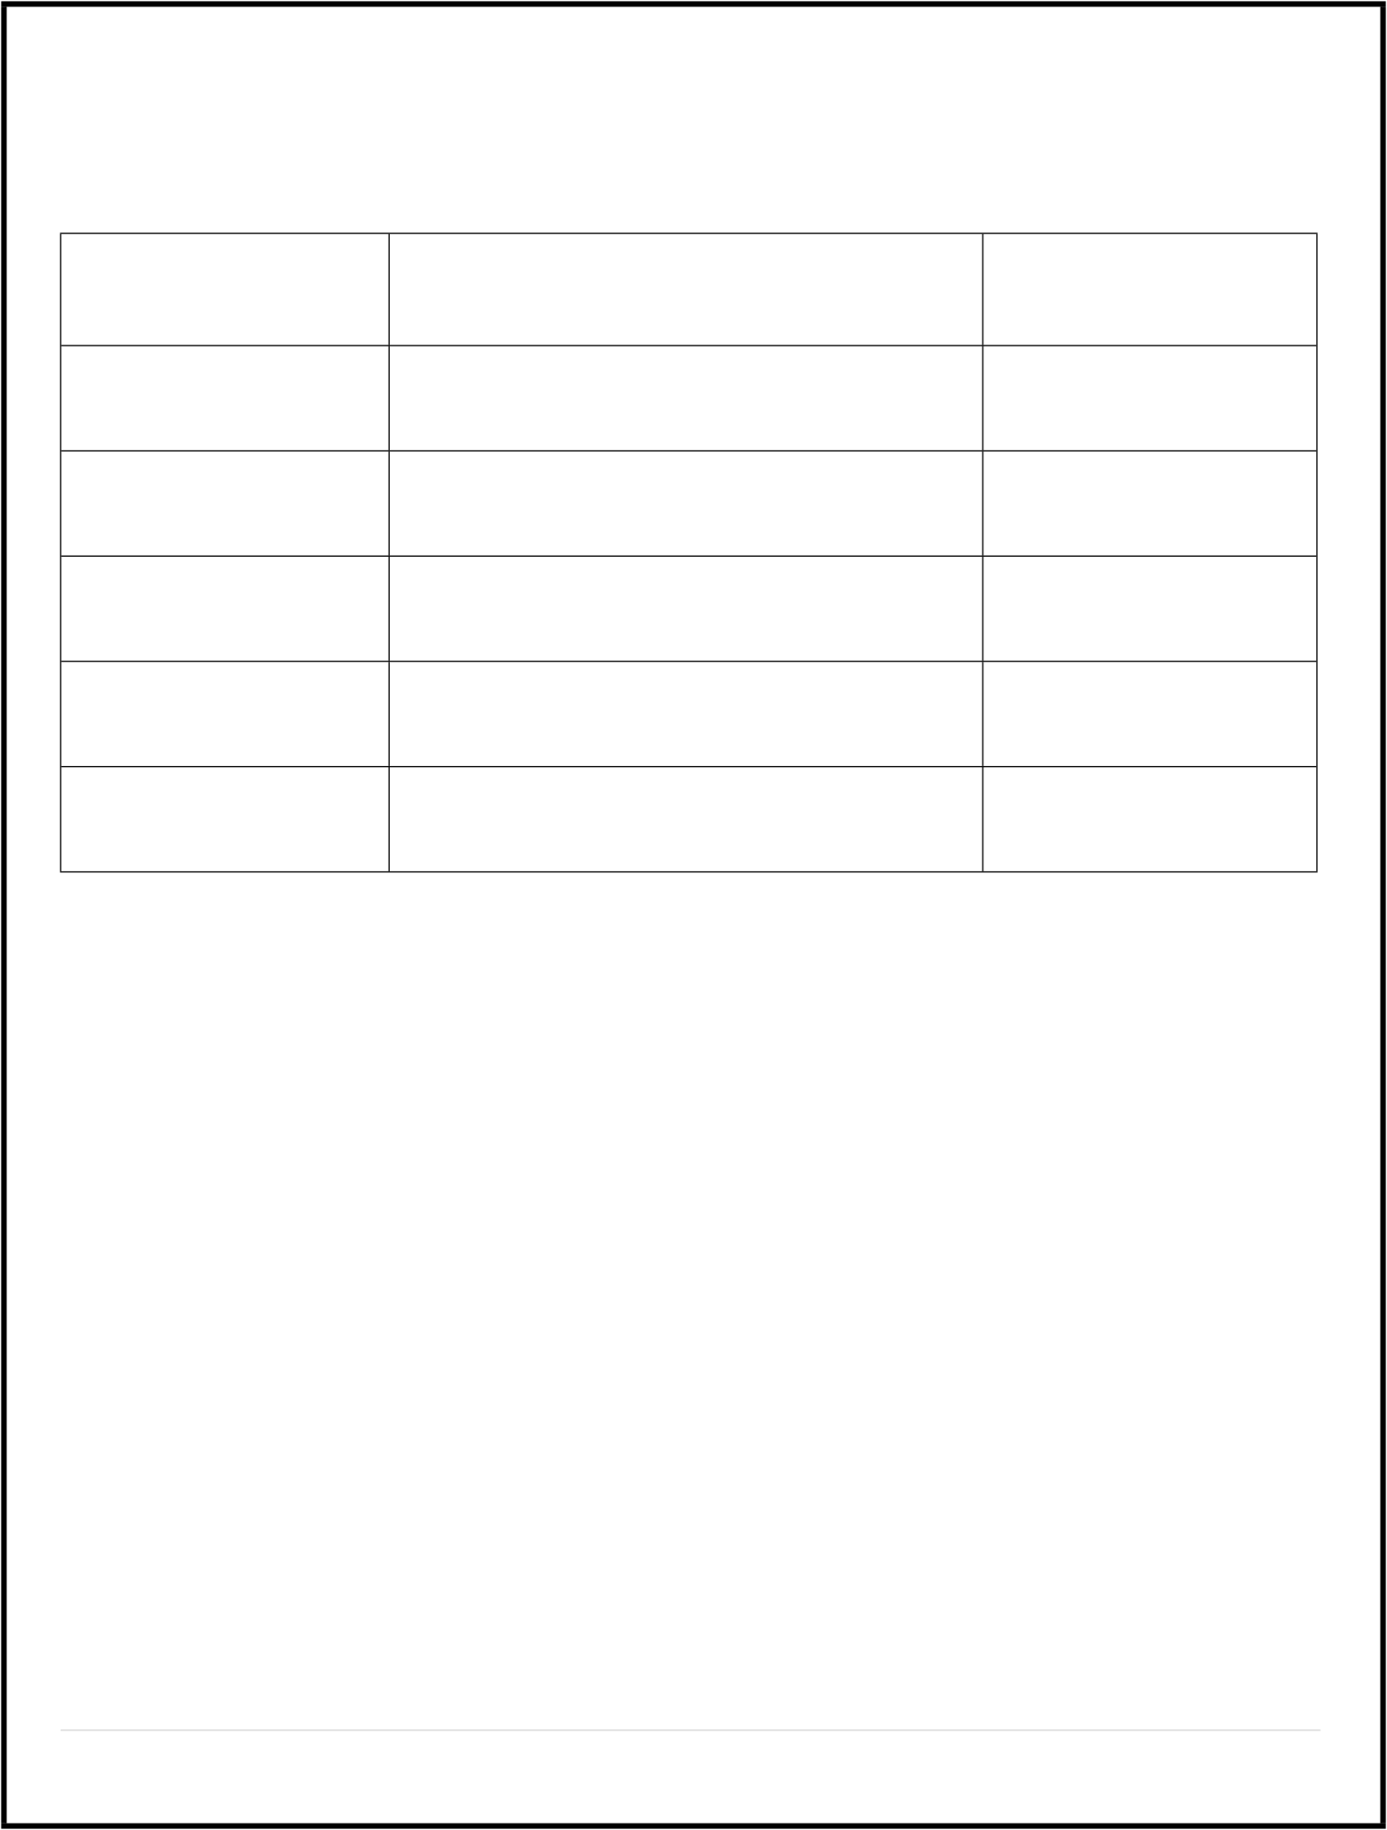
- CONCLUSION 9

2 | Page

INTRODUCTION
With the rapid growth of the hospitality sector and increasing consumer preference for convenience, an efficient digital solution for managing restaurant reservations is essential. Customers traditionally rely on phone calls or walk-ins to reserve tables, often leading to miscommunication, booking conflicts, or unorganized records. Such conventional methods lack centralized management and can result in overbookings or missed opportunities to maximize restaurant capacity.
The proposed system, “Restaurant Booking System,” aims to resolve these challenges by offering a web-based platform that enables both customers and restaurant administrators to handle table reservations seamlessly. Customers can check real-time table availability, reserve a spot for their
preferred time and date, receive instant confirmations, and view details about the restaurant’s menu and facilities. Restaurant staff and managers can access an admin panel to oversee bookings, manage seating arrangements, block unavailable slots, and generate reports for operational insights.
Leveraging modern web technologies like React.js for interactive interfaces, Node.js with Express.js for backend logic, and MongoDB for managing booking and user data, the system guarantees reliability, scalability, and a user-friendly experience. By integrating secure authentication and data privacy measures, the Restaurant Booking System ensures efficient table management and elevates customer
satisfaction in a competitive market environment
3 | Page

Objective Of The Project :

- Develop an interactive platform for easy restaurant reservation and table management.

- Ensure secure authentication for customers, staff, and admin users.

- Allow real-time booking, viewing, modification, and cancellation of reservations.
- Implement search features for available tables, restaurant timing, and location.

- Provide an admin panel for monitoring, analytics, and capacity planning.

- Maintain data integrity and protect user privacy

Scope :

- The system will cater to restaurants aiming to digitize their booking operations and improve customer experience.

- Accessible via any web browser (desktop and mobile).
- Initial version focuses on table reservation management, customer notifications, and admin control.
- Built to allow future extension with AI-driven booking recommendations and integration
- for online food ordering

TECHNOLOGY USED

- Layer Technology
- Front-End HTML5, CSS3, JavaScript, React.js
- Backend Node.js, Express.js
- Database MongoDB (NoSQL)
- Auth JSON Web Tokens (JWT)
- Other hosting (Firebase/AWS S3 optional for media/files)

- Platform
Google Chrome/Web browsers

LAYOUT OF PROPOSED WORK
- User Registration/Login: Customers create accounts or sign in for personalized bookings and history.
- Users see reservation status, create new bookings, or edit/cancel existing ones.
Dashboard Access:
- Customers select date, time, party size, and restaurant section; staff approve or auto-confirm within limits.
Table Booking/Modification:
- Users filter by date, time, location, amenities, or cuisine type.
Search Feature:
- Managers verify bookings, manage blocked slots, and generate usage reports.
Admin Monitoring:
Proposed Layouts
- Homepage: Restaurant overview, login/signup, featured menus.
- User Dashboard: Upcoming reservations, booking options, notifications.
- Admin Panel: Table management, user access, analytics, booking


Admin Modules
- Manage users and reservations (approve, block, delete)

- Monitor table availability and seating arrangements

- Generate reports on booking patterns and operational efficiency

- Block off tables for maintenance or special events

USER MODULES

  - Secure registration and login

  - Book, view, modify, or cancel reservations

  - Search for available tables by time/date

  - View menus or restaurant details

Guest Modules
- View homepage and restaurant introduction
- Cannot make reservations without registration
- Prompt for user registration and login

7 | Page

ROLE OF TEAM MEMBER
Member Name
Role of Team Member
Rudra singh,Sagar gautam
Back-end
Raunak pandey ,Sajal dwivedi
Front-end
Raunak pandey
Documentation

CONCLUSION

The proposed Smart Online Notes The proposed Restaurant Booking System overcomes the challenges of manual reservation management by providing a centralized, secure digital solution for restaurants and customers. It delivers significant improvements in booking efficiency, reduces errors, and enhances the overall dining experience. Flexibility in design allows for future incorporation of advanced features like AI- driven reservation analytics, dynamic pricing, and deep customer profiling. The adoption of this system contributes to greater operational productivity, customer satisfaction, and modernization of restaurant services suitable for today’s technology-driven world

